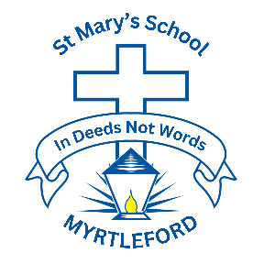
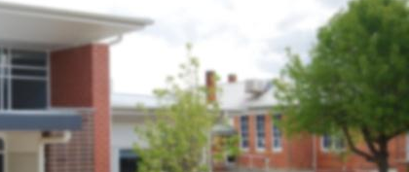
St. Mary’s Primary School Newsletter
43 O’ Donnell Ave.
(P.O. Box 320)
Myrtleford Victoria 3737
Phone: 03 5752 1808
e-mail: principal@smmyrtleford.catholic.edu.au
web: www.smmyrtleford.catholic.edu.au
School Notices
Yard Supervision:
Morning: 8:30 - 8:55am
Afternoon: 3:20 -3:35pm

Bell Times:
School Begins 8:55am
Recess: 11:10–11:30am
Lunch: 1:30 -2:20pm
Finish: 3:20pm

Student Absences:
Please phone the office by 9:00am if your child will not be at school on 57 521808.
Or mark absence on PAM.


TERM 2
20th April –
26th June
TERM 3
Monday 13th July-
Friday 18th September
TERM 4
6th October -
19th December

MASS TIMES
Myrtleford
Saturday @ 5:00pm
Sunday @ 9.00am
Bright
Sunday @ 11:00am
St Patricks Whorouly
Last Sunday of the Month @ 5:00pm

 Click on the link

Date: 4th June, 2026 Newsletter No: 9 Term: 2 - Week: 7

REMINDER ABOUT OUR SCHOOL CLOSURE DAYS
Friday 5th June - Pupil Free Day
Monday 8th June - Public Holiday
Thursday 11th - Pupil Free Day

PRINCIPAL MESSAGE
It has been a rich and meaningful week at St Mary’s as we came together to honour National Reconciliation Week. Our whole school liturgy was a powerful celebration of truth, respect, and unity, reminding us of the importance of walking together with Aboriginal and Torres Strait Islander peoples in a spirit of reconciliation. Throughout the week, students participated in a variety of engaging learning experiences that deepened their understanding of culture, history, and the ongoing journey toward justice. It was inspiring to see such thoughtful reflection and respectful engagement across all year levels.

As we continue our journey of faith, we ask you to keep the students preparing to receive the Sacraments of Eucharist and Confirmation in your thoughts and prayers. This is a special time in their spiritual lives, and your support as families strengthens their sense of belonging to our faith community.

This week’s celebration of Pentecost provides a beautiful connection to these sacraments. At Pentecost, we remember the coming of the Holy Spirit, who filled the disciples with courage, wisdom, and faith. We pray that the same Spirit will guide our students as they prepare to receive these important sacraments, inspiring them to live out the Gospel with love and compassion.

Thank you, as always, for your continued support and partnership in nurturing the faith and learning of our students.

Andrea O’Connor

MRSA (GOLDEN STAPH)
There has recently been a case of MRSA (Golden Staph) at St Mary’s Primary School. Considering this, we would like to provide health guidance regarding MRSA, a common bacterial skin infection that can present as red, swollen sores or boils. Families are encouraged to seek medical advice if they notice any signs of a possible skin infection.

Students can attend school if any wound is clean and securely covered and they are able to maintain good hygiene. Students should stay at home if wounds are open, weeping, cannot be covered, or if they are unwell.

To minimise risk, the school is reinforcing regular handwashing, covering of wounds, and avoiding the sharing of personal items such as towels and drink bottles.
How families can help:
- Keep any cuts or sores clean, dry, and covered
- Encourage good hand hygiene
- Avoid sharing personal items
- Seek medical advice if a skin infection is suspected
- Inform the school if your child is diagnosed with MRSA
Key message: MRSA is manageable, and with proper precautions, students can safely attend school.
SCHOOL NEWS

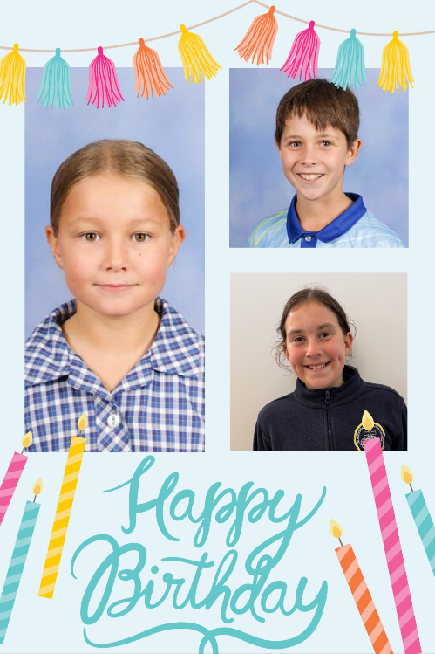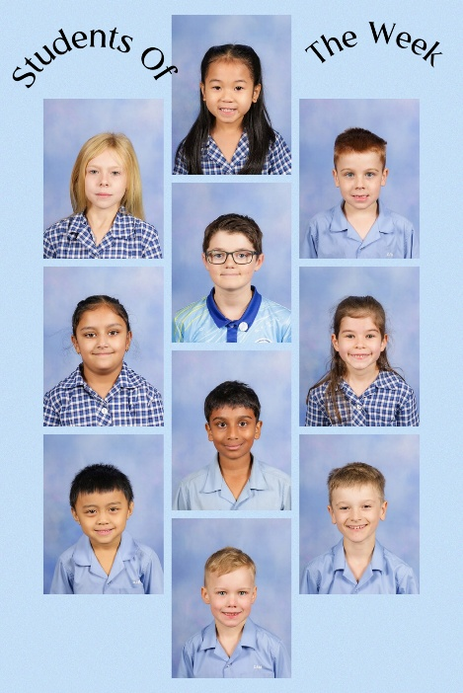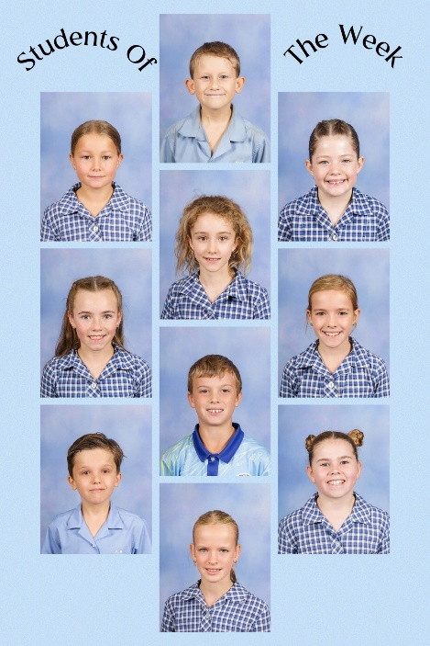

DATES TO REMEMBER
JUNE
Friday 5th | School Closure Day (Wellbeing: CESL)
Monday 8th | Public Holiday
Thursday 11th | School Closure Day
Friday 12th | Regional Cross Country
Friday 12th | Assembly 2:20pm Nagle Centre
Friday 19th | St Mary’s Performing Art Festival
Sunday 21st | Confirmation & Eucharist Mass 9am
Monday 22nd | Ovens & Mitta Division Winter Sports (Year 5/6)
Wednesday 24th | Whole School End of Term Mass 11:30am
Thursday 25th | School Reports Released via SIMON
Friday 26th | Last Day Term 2

RECONCILIATION WEEK – THEME: ALL IN LITURGY LAST WEEK
Thank you to the staff and students for the way everyone contributed towards Reconciliation Week last week. We had a lovely liturgy to remember Sorry Day and celebrate Reconciliation Week last Friday.
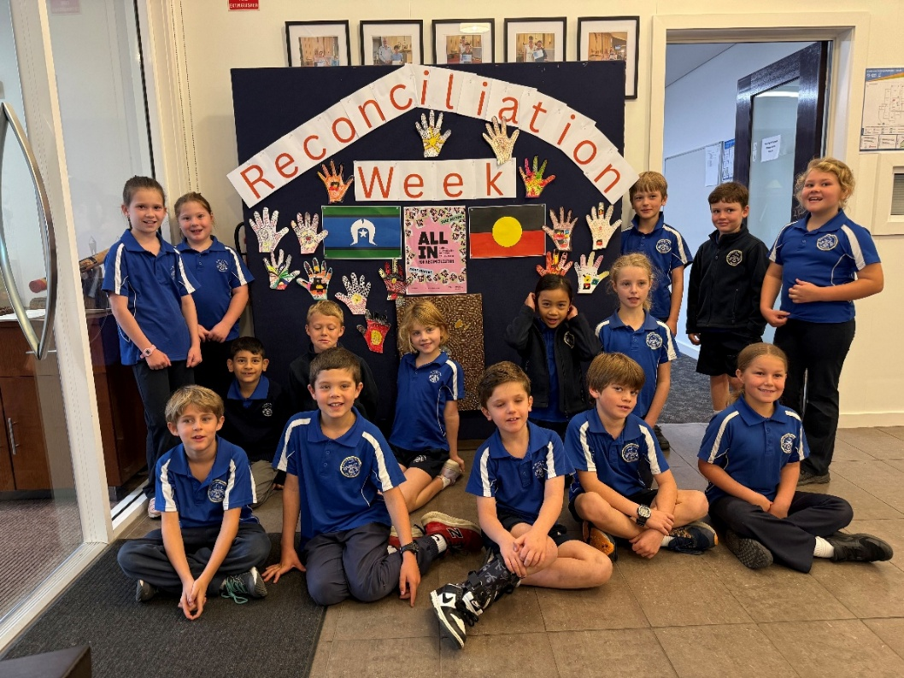


FIRE CARRIERS – FRIENDS IGNITING RECONCILIATION THROUGH EDUCATION
Congratulations to the following students who have volunteered to become FIRE Carriers. This means that these people will help to keep the fire of truth, justice and reconciliation burning by learning, sharing and walking together. This is a wonderful commitment from these Year 5/6 students and one that they can continue to carry with them beyond St Mary’s School. We also welcome Mrs Reynolds-Smith who has also put her name forward for this honour.

Students and staff become FIRE Carriers — people who help keep the fire of truth, justice, and reconciliation burning by learning, sharing and walking together. The program is to promote respect, fairness and inclusion for Aboriginal people.
Stephanie Hellebrand, Zoe Richter, Brodie Pozzan, Ivy Lewis, Lui Iaria, Harry Hoffman, Heidi Murray, Maddie Sultana,
Lachlan Earl, Maddie Rae, Pippa Carroll, Kaydence Hedges, Max Dittko, Evie Hoffmann, Maisie Fitzpatrick and Mrs Reynolds-Smith.


We welcome Michael Chisolm on Friday, June 12th who will be speaking with the students about their new responsibility as a FIRE Carrier. We will be presenting these people to the school community at our assembly on that day.

FIRE COMMISSIONING CEREMONY – FRIDAY, JUNE 26 @ 12:30PM
The students will take part in an official FIRE Commissioning Ceremony on the last day of Term Two (Friday, June 26 at 12:30pm). Michael will return to school on this day to officiate the ceremony.

JLC NEWS

FOUNDATION
It has been a positive couple of weeks in Foundation. The students have continued to build confidence with classroom routines and have been working hard across our literacy, mathematics, religion and wellbeing learning.

WRITING
In InitialWrite, we have been learning to add more detail to our ideas. Students have been describing likes and dislikes, describing characters, writing words and beginning to write labels. We have also continued practising saying our ideas first, drawing to match our thinking and then having a go at writing. This helps students understand that their writing needs to match the message they want to share.

READING AND SPELLING
In InitiaLit, we have started working through Phonic Set 4. Students have been learning new sounds and linking these sounds to letters, including e and n. We will also continue working with g and l as we move through this set. Students have been practising reading and spelling simple words using the sounds they know. We have also been working on text reading, writing and tricky words such as they, that, said and are.

STORYBOOKS
Our storybook lessons continue to be a great part of our learning. We have been reading The Potato People and using the story to build our listening, speaking and comprehension skills. Students have been encouraged to talk about the characters, share their ideas, answer questions and make connections to the story. These lessons also help students practise using full sentences when sharing their thinking.

MATHEMATICS
In Mathematics, we have been learning about shape. Students have been identifying, naming and making common shapes, including circles, triangles, rectangles and squares. We have also been matching shapes to spaces and sorting objects in different ways. These activities are helping students notice shape features, describe what they see and explain how objects can be grouped.

RELIGION
In Religion, we have been learning about the Church as a community of people. Students have been talking about how the early Church helped others and how parishes continue to help people today. We have also discussed that parishes help beyond the church building, including through groups such as the St Vincent de Paul Society. The students have been encouraged to think about how we can also be caring community members.

WELLBEING
In RRRR, we have been focusing on positive coping and problem-solving. Students have been learning to notice emotions, use calm time strategies and think about different ways to solve small problems. We have also been talking about listening to others’ ideas, recognising that people may see things differently and working together in a positive way.

HOME READING
Thank you for your support with home reading. Reading together at home is a valuable way to build confidence, enjoyment and a love of books. A short routine of 5–10 minutes, a few times a week, can make a big difference.
Families can support reading by looking at the cover, reading the title, talking about what the book might be about and asking a few questions after reading. It is also helpful to encourage your child to have a go at sounding out words using the sounds they know. If a word is too tricky, it is fine to help them and keep the reading experience positive.

The sounds and words packs that have been sent home can also be used as short booster sessions. Practising these letters, sounds and words alongside home reading will help consolidate what we are learning at school. Reading picture storybooks together is also very important and can be recorded in the reading diary. The main aim is to keep reading at home calm, positive and enjoyable.

REMINDERS
Sports Uniform - Sports uniform days for Term 2 are Wednesday and Friday.
School Closure Day - A reminder that Friday 5 June is a school closure day.
School Nurse Health Assessment - A free health assessment is offered to all children in their first year of primary school. This program includes vision and hearing screenings and is run by the Department of Education. Information about completing the questionnaire online will be shared with families through our online platform. Forms need to be submitted online by Friday 12th June, 2026. If you would prefer a hard copy of the questionnaire, please let your child’s teacher know. Our visiting school nurse this year is Sue Anglim.
Jumpers - Please make sure all jumpers are clearly labelled with your child’s name, as they can be easily mixed up during the day.
Blue Library Bags - Please remember to send blue library bags to school each day. These are used for library borrowing, home ading materials, information notes and letters.
Reading Diaries - Please continue to return reading diaries in blue library bags so they can be checked and signed.

YEAR 1
This week we farewelled Miss Demi Johns from our classroom. Demi finished her teaching placement from La Trobe University on Monday.

WRITING
We have been learning how to write an information text. Students have been practising writing factual sentences about a topic, and this week our focus has been Spiders. They have learned to write a clear heading, give facts rather than opinions, stay on one topic, and use correct vocabulary such as fangs instead of teeth.

Students have also been working on using connecting words and commas to join ideas, for example: A spider has fangs, it spins a web, and it eats flies. They have also been learning to use proper nouns accurately, especially when writing the names of places, and people, using capital letters for these important words.

TRICKY WORDS
We are revising the tricky words: love, over, says and will be doing mother, sister and brother.

MATHS
Students are learning to represent addition stories within 20 by using ten-frames to show quantities visually and build strong number sense. They are also exploring number bonds to represent addition within 20, helping them understand how numbers can be broken apart and recombined. As part of this learning sequence, students are being introduced to the addition and equals symbols and are beginning to use them to record their thinking. They are also learning that the equals symbol represents equivalence, not just an answer, and are practising writing number sentences that show balanced relationships such as 7 + 3 = 5 + 5.

RELIGION
Students will be learning about grief, loss and suffering in religion for the remainder of the term. We will explore different types of loss, the feelings that come with change, and healthy ways to express emotions. They will learn that God loves each of us, is present in all stages of life, and that Christians believe in eternal life. We will also talk about remembering loved ones, the cycle of life, and simple rituals that help us say goodbye. Students will consider how we can support others who are grieving and understand that feeling sad is a natural part of loving and letting go.

YEAR 2
Next week, we welcome back our student teacher, Miss Grace who was with us for two weeks and will be returning for another two weeks.

ENGLISH
Fluency reading continues to be an important part of our morning routine and it was pleasing to see growth in recent fluency assessments with the students. Each week, we learn 3 new ‘tricky words’ and how to read and spell them. These are featured in the back of the Home Reading book and I really encourage you to get the students to practise spelling these words (oral or written) as often as possible, especially when there is one or more words that the children are struggling with.
This week’s ‘Tricky Words’ are tomorrow, school and cousin.

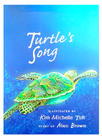
Our text for Week 7 and 8 is ‘Turtle’s Song’ by Alan Brown and Kim Toft. It tells the story of a Green Turtle from hatchling on beach, through to adulthood and returning to lay eggs of its own.

HOME READER DIARIES
Just a reminder that these are due back to school each Friday, so that new books can be given to students. Thank you to the families who are continuing to listen to their students read regularly.

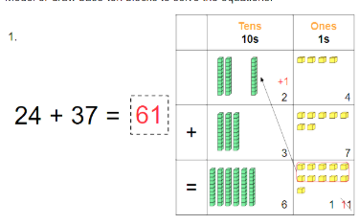
MATHS
We’re finishing up our unit on Addition and Subtraction with an assessment this week.
Doubles and near doubles (2+2=4, 3+3=6, up to 10+10=20). The near doubles are the same doubles with one number more or less. For example 7+8=15 (like double 7 but plus one more).
Adding and Regrouping We’ve also learning about how to regroup when we are adding 2 digit numbers: We have been using our Base 10 Blocks (Tens and Ones) to help us understand this. It has been a tricky topic for a few of the students.

RELIGION
A note about our new topic ‘Grief and Loss’ was sent out earlier in the week. Please have a read if you have not done so already.

RRRR (RESPECTFUL RELATIONSHIPS) - STRESS
Students are learning to recognise what stress can feel like in their bodies and minds, and that it’s a normal part of everyday life. We discussed common situations that might cause stress (such as waking up later than expected!) and the children came up with many simple, healthy ways to manage these feelings, such as talking to a trusted person, taking calming breaths, and using positive thinking strategies, playing with their pet, enjoying nature and looking at the clouds! The students were introduced to an imaginary character, ‘Wibbly’ to help them in this week’s lesson.

Have a lovely, extra long weekend!
Leigh, Sandra, Carolyn, Nicole, Anna, Demi and Julie

MLC NEWS

The Year 4 students have been engaging enthusiastically with our new book study, The Arrival. Although the text is wordless, its powerful illustrations have inspired rich imagination and thoughtful discussion. I have been impressed by the students’ insights and their attention to detail.

We are also focusing on strengthening times table recall to support more complex mathematical problem-solving. Students are practising daily, working to improve both speed and accuracy. Currently, we are concentrating on the 4 times tables and will continue until all students achieve automatic recall. Please support your child at home if they are still developing confidence in this area.

I am thoroughly enjoying working with your children and appreciate your ongoing support while Jo is away. We wish her a smooth and speedy recovery.

Mrs Hancock

SLC NEWS

We thank Cath Jeffery for her work in 5/6 RR in the last week and we keep Regina in our prayers as she navigates this difficult time.

THE GOOD, THE BARD AND THE AUSSIE
Last week was a busy one with a difference. On Wednesday, the students were very fortunate to attend the dress rehearsal of the Marian College play - "The Good, The Bard and the Aussie". We spent Monday familiarising ourselves with the writings of William Shakespeare and the complex plots of: Hamlet, Macbeth, Romeo and Juliet, Antony and Cleopatra as well as the comedies – As You Like It and Much Ado About Nothing. We had great discussion about the themes of the tragedies and comedies and the many sayings that can be attributed to Shakespeare’s writing.

Some familiar sayings from Shakespeare's writing include:
as luck would have it budge an inch for goodness sake seen better days
green eyed monster my own flesh and blood tower of strength dead as a doornail
it smells to high heaven vanish into thin air too much of a good thing foul play

MATHS
The students have been working on fractions and completed an assessment on this topic. We will revisit this topic again later in the year. We are currently learning about probability. We should ask questions such as – what a the chances of rain at 3:20 on a week day? It seems likely at times. Please encourage your child to work on a times table they are unfamiliar with, it makes all the difference when completing the four operations or fractions.

RELIGION
What a lovely Liturgy on Friday. The students engaged well in Reconciliation activities and Sorry Day and we thank those students who volunteered to read. The students also worked on tasks and explored the significance of Sorry Day.
A reminder that students only wear sports uniform on sport and Bluearth days.

Have a great week
SLC Teachers.

SPECIALIST NEWS

VISUAL ARTS
Students have been busy creating beautiful ‘Torn Paper Gardens’ in Visual Arts this fortnight. Inspired by colourful cottage gardens, students first used torn pieces of tissue paper to create vibrant backgrounds that explore colour, texture and composition.

They are now building their gardens by carefully tearing and layering additional tissue paper to create flowers, plants and garden features. Students are learning how overlapping shapes can create depth and interest within an artwork. The project also provides valuable opportunities to develop fine motor skills, as well as practise patience and attention to detail.

We are looking forward to seeing each unique garden come to life as students continue adding layers, colour and creativity to their masterpieces!

Also, please visit the display cabinet in our foyer to see the incredible mini fruit bowl sculptures that the Year 2 and Year 5/6 created using clay. They will certainly make you smile as you admire the attention to detail in a pod of peas or a bunch of bananas!

PERFORMING ARTS
What a fantastic buzz there has been in Performing Arts lately!
Our Year 3–6 students have been diving into the world of music, exploring beat, rhythm, and tempo while also learning how to read and use music notation. They’ve been putting their skills into action by composing their own rhythms on the African drums—and the results have been amazing!

It has also been wonderful to see students confidently sharing their own musical talents during lessons, with some showcasing
their skills on the guitar and piano. We love seeing creativity and confidence shine!

We are incredibly excited to announce our very first St Mary’s Performing Arts Festival, happening on Friday 19th June at EMPAC. Participation is voluntary, and we already have a fantastic line-up of students preparing to perform dance, drama, and musical pieces. It’s shaping up to be a wonderful celebration of talent and creativity!
More details will be shared with families closer to the event—stay tuned!

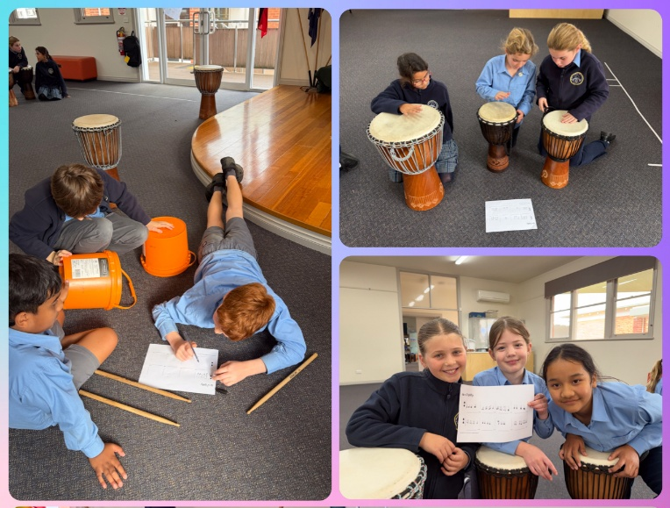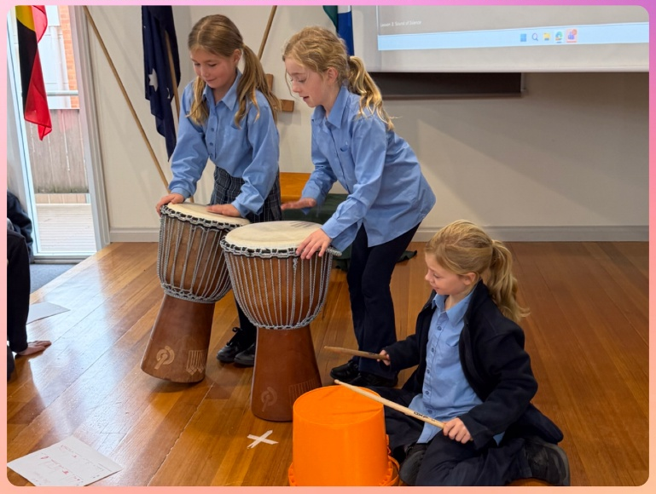

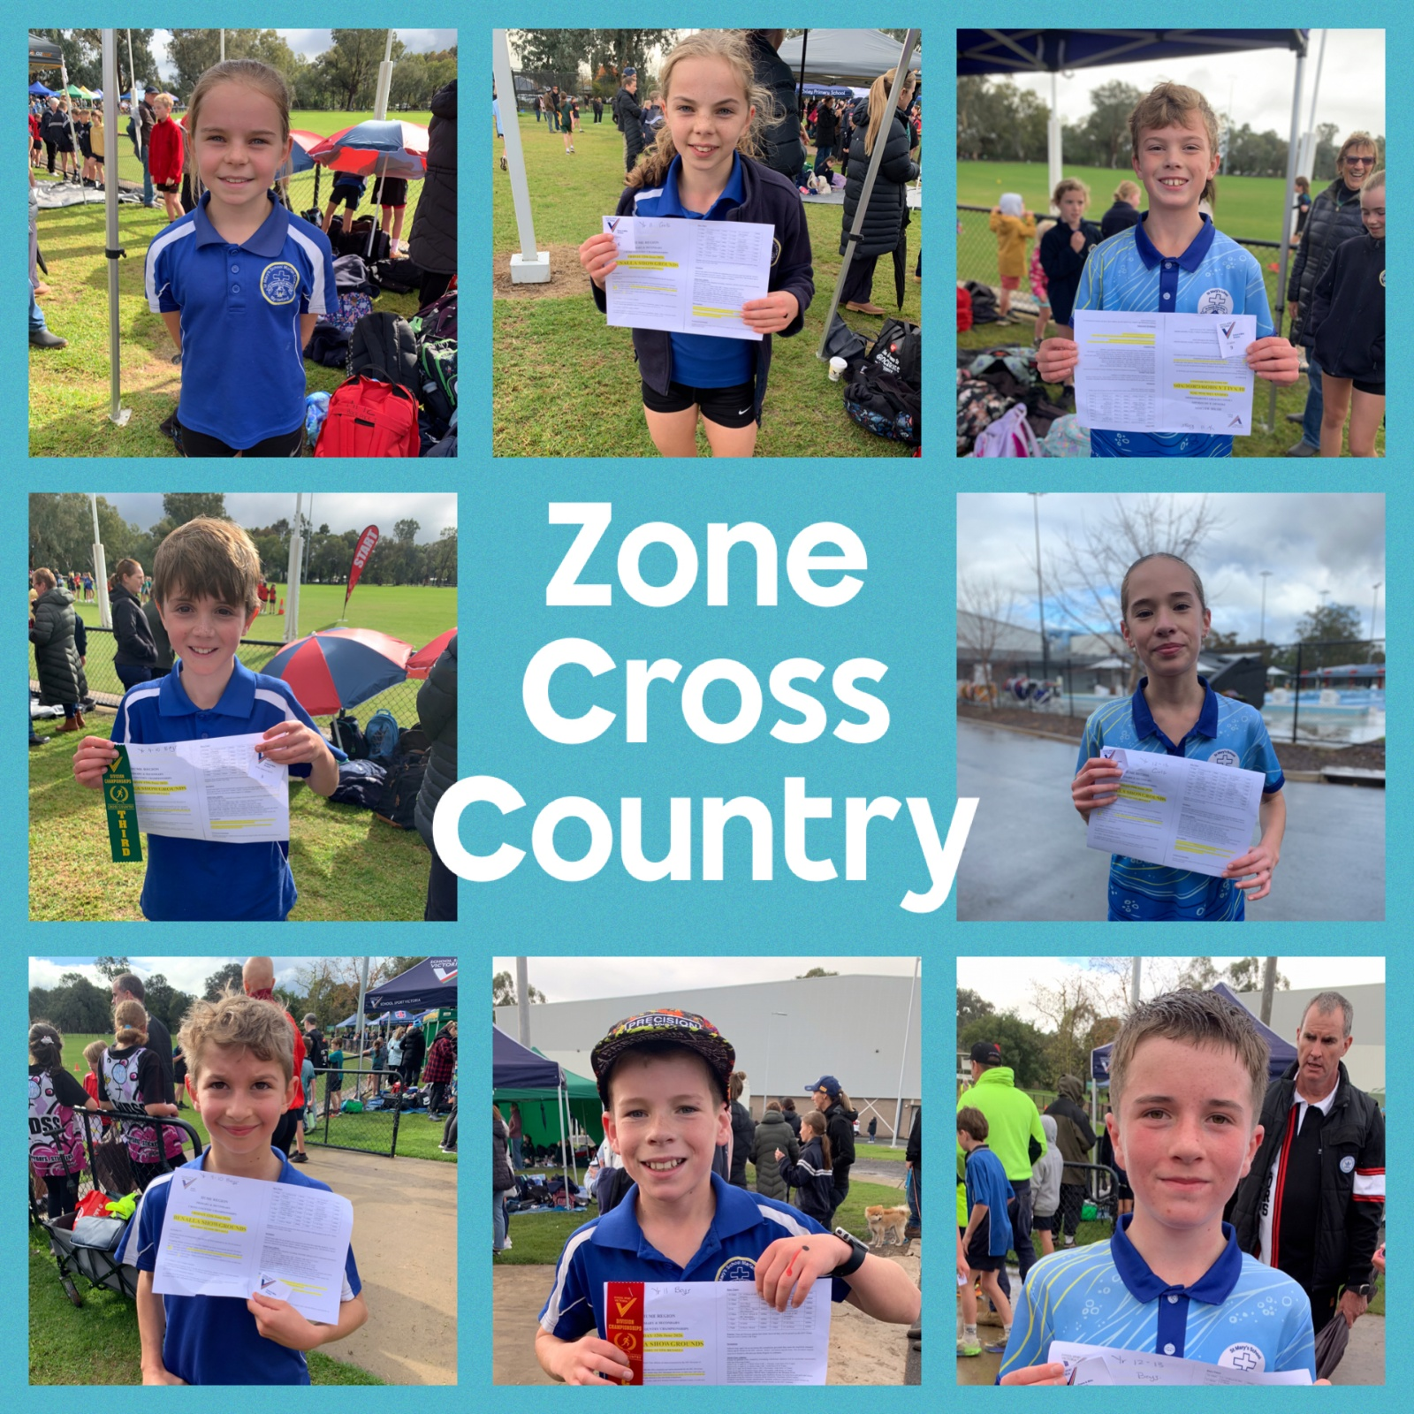

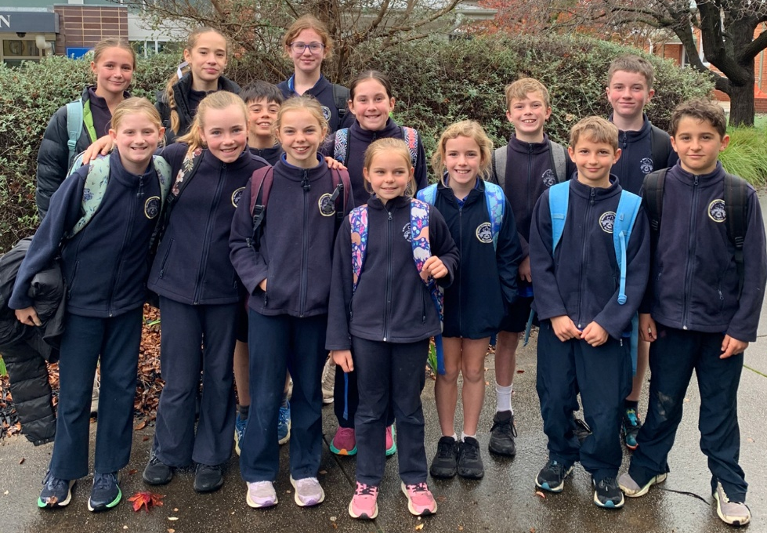
Congratulations to all the children that competed at the Zone Cross Country yesterday. We will have more information on this in the next newsletter.


PIE & LAMINGTON ORDERS – IMPORTANT DATES
Please ensure all orders and payments are submitted by 10th June online, as late orders cannot be accepted.
Items will be available for collection on 18th June.

Instructions on how to order and pay are on the bottom of the order form.
A hard copy of the order form was sent home with the oldest in the family yesterday.

Thank you for supporting our school!

COMMUNITY NEWS

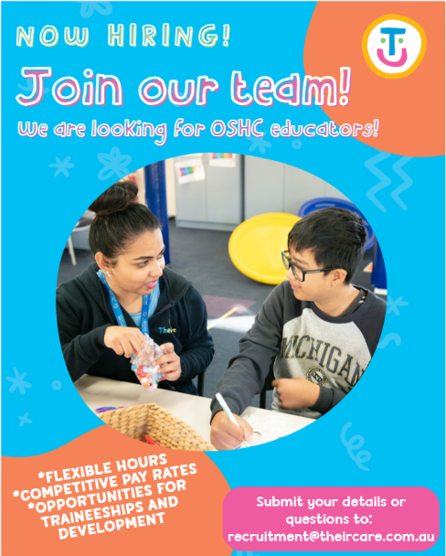
WE’RE HIRING – JOIN OUR AMAZING TEAM!
Do you love working with children and making a difference in their day?
Here’s your chance to be part of the TheirCare Team – where every day is fun, rewarding, and full of smiles!

We’re on the lookout for passionate and caring people to join our team for:
- Before School Care
- After School Care
- School Holiday Programs
We have services at Myrtleford.

If you hold a Certificate III or Diploma in Childcare, Education Support, or another relevant qualification, this could be the perfect role for you! Earn up to $45 per hour.

Bonus: If you’re already working as Education Support at a local school, this is a fantastic way to earn extra income and keep busy during the holidays.
Apply Today!
Send your resume to recruitment@theircare.edu.au and start your journey with a team that values fun, teamwork, and creating memorable experiences for kids every day.
-------------------------------------------------------------------------------------------------------------------------------------------------------------
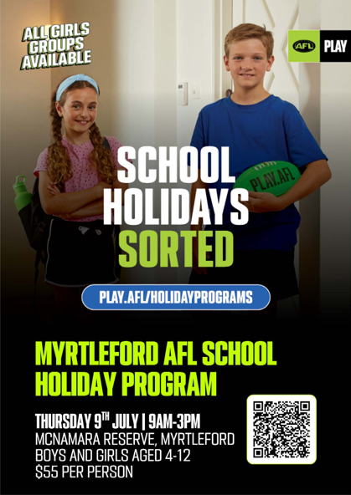

AFL Victoria is excited to be running a School Holiday Auskick and Superkick Program in Myrtleford during the upcoming school holidays.

The program will take place on Thursday 9th July from 9:00am – 3:00pm and is designed to provide children with a fun, active and engaging day of football activities in a welcoming environment.

Date: Thursday 9th July
Time: 9:00am – 3:00pm
Program: Auskick & Superkick School Holiday Program
Location: McNamara Reserve
Registration Link: https://play.afl/club-finder-map?formats=holiday_programs&orgId=4623b9cc-5a7b-45f1-ba83-6d6960b6be6f

The program caters for children of varying skill levels and provides a great opportunity for participants to stay active, build confidence and enjoy football during the school holidays.

